Project Tittle: CodeClause Internship

CodeClause Internship is a dynamic program designed to bridge the gap between academic knowledge and real-world software development practices.

Recognizing the vital role of internships in preparing the next generation of tech industry leaders, CodeClause offers an immersive experience that aligns with the rapidly evolving demands of the IT sector.

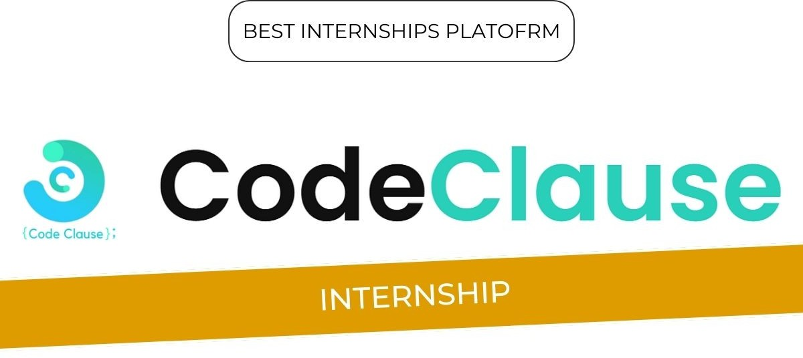

The primary objectives of this program are to provide practical skills, foster innovation, and cultivate a community of collaborative learners.

# Internship Structure

* **Duration:** The CodeClause internship program has a duration of 1 month.
* **Eligibility Criteria:** The internship is open to applicants pursuing a B.Tech degree in Computer Science and Engineering or related fields.
* **Selection Process:** Applicants undergo a rigorous selection process to be chosen for the internship.
* **Training and Development:** Interns are provided with challenging opportunities and real-world projects to work on, allowing them to demonstrate their abilities and enhance their skills.
* **Mentorship:** Interns receive guidance and feedback from industry experts and mentors throughout the internship program.
* **Certifications:** The CodeClause internship program offers prestigious certifications such as MCA and MSME, as well as ISO certification, attesting to the quality and excellence of the training.
* **Partnerships:** CodeClause has partnerships with over 300 colleges, providing a diverse pool of interns from various backgrounds and locations.

# Internship Modules

* **Diverse Domains:** The CodeClause internship program covers a wide range of domains, including Artificial Intelligence, Data Science, Web Development, Java Development, Android Development, Python Development, Graphics Design, and Content Writing.
* **Hands-on Projects:** Interns are given the opportunity to work on real-world projects and assignments that allow them to apply their learning and develop practical skills.
* **Industry-Relevant Training:** The training provided by CodeClause is focused on equipping interns with the latest industry trends and technologies, ensuring they are well-prepared for the evolving digital landscape.
* **Mentorship:** Interns receive guidance and mentorship from industry experts throughout the program, helping them to develop their skills and grow professionally.
* **Certifications:** The CodeClause internship program offers prestigious certifications such as MCA and MSME, as well as ISO certification, demonstrating the program's commitment to quality and excellence.
* **Adaptability:** The internship modules are designed to be flexible and responsive to the changing needs of the tech industry, ensuring that interns are equipped with the skills to adapt and innovate.

# Benefits for Interns

The CodeClause internship offers a wide range of benefits for interns, including:

## Networking Opportunities

Interns at CodeClause have the opportunity to network with business leaders, mentors, other interns, and possible employers, allowing them to build important contacts and learn about the tech industry through networking events, industry conferences, and internal meetups.

## Career Development

The internship is designed to pave the way for exponential career growth, offering immersive experiences that translate academic knowledge into industry prowess. Interns can collaborate, learn, and grow in a digital environment, no matter where they are.

## Practical Learning

The program focuses on practical learning, equipping interns with the skills to excel in the tech world. With expert-led sessions covering the latest industry trends and technologies, interns can develop hands-on skills and apply them to real-world projects.

## Flexibility

The internship is designed to adapt to the intern's schedule, allowing them to learn and grow without compromising on personal commitments. This flexible approach respects the intern's time and ensures that they can balance their personal and professional responsibilities.

## Prestigious Certifications

The CodeClause internship program offers prestigious certifications such as MCA and MSME, as well as ISO certification, demonstrating the program's commitment to quality and excellence in the tech sector.

## Global Community

The program has a global footprint of over 70,000 interns from more than 17 countries, showcasing a rich environment of learning and professional growth. This vast network represents a melting pot of innovation, skills, and opportunities, propelling careers forward on an international scale.

## Recognition

The program has received recognition from various organizations, including AICTE Approval and recognition by Startup India, highlighting its alignment with educational excellence and innovative entrepreneurial spirit

## Community Engagement

The CodeClause internship has a strong presence on LinkedIn, with many interns sharing their experiences and the value they gained from the program. This community engagement is a testament to the program's impact on its participants.

**Conclusion**

The CodeClause Internship is more than just a training program; it’s a launchpad for aspiring tech professionals. We encourage all interested individuals to seize this opportunity to transform their potential into expertise. Apply now and take the first step towards a promising career in technology.